**STEPS TO RUN BITCOIN NODE IN WINDOWS**

* **Just follow the following steps and run bitcoin node in your pc :**
* First we need to download bitcoin core in our pc.

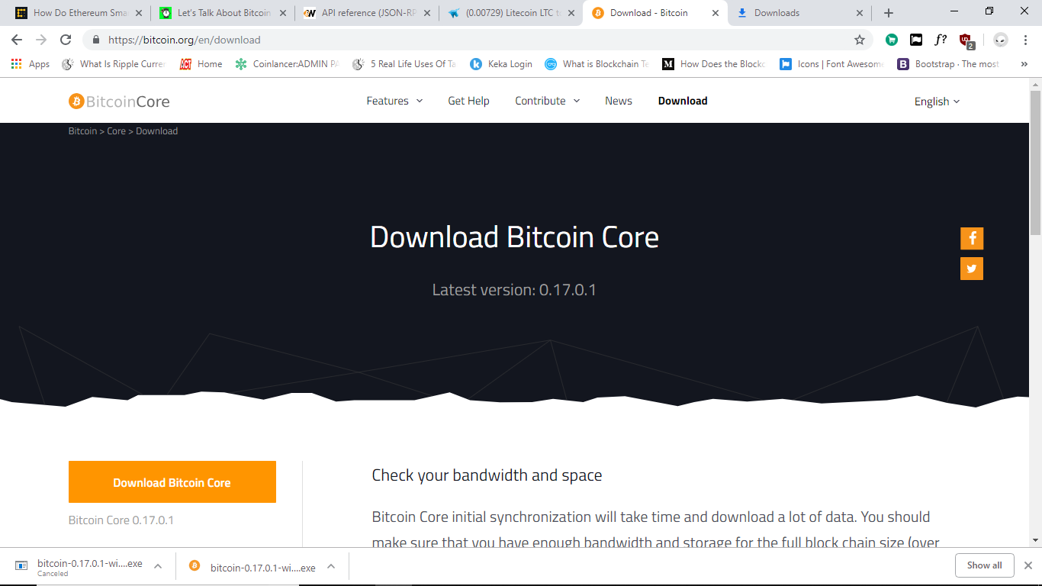

* We need install bitcoin core in our pc.
* After completion of bitcoin core installation run on your pc.
* Create the path to run in command prompt as given below :

1. Get the path from file and create in environment as shown below

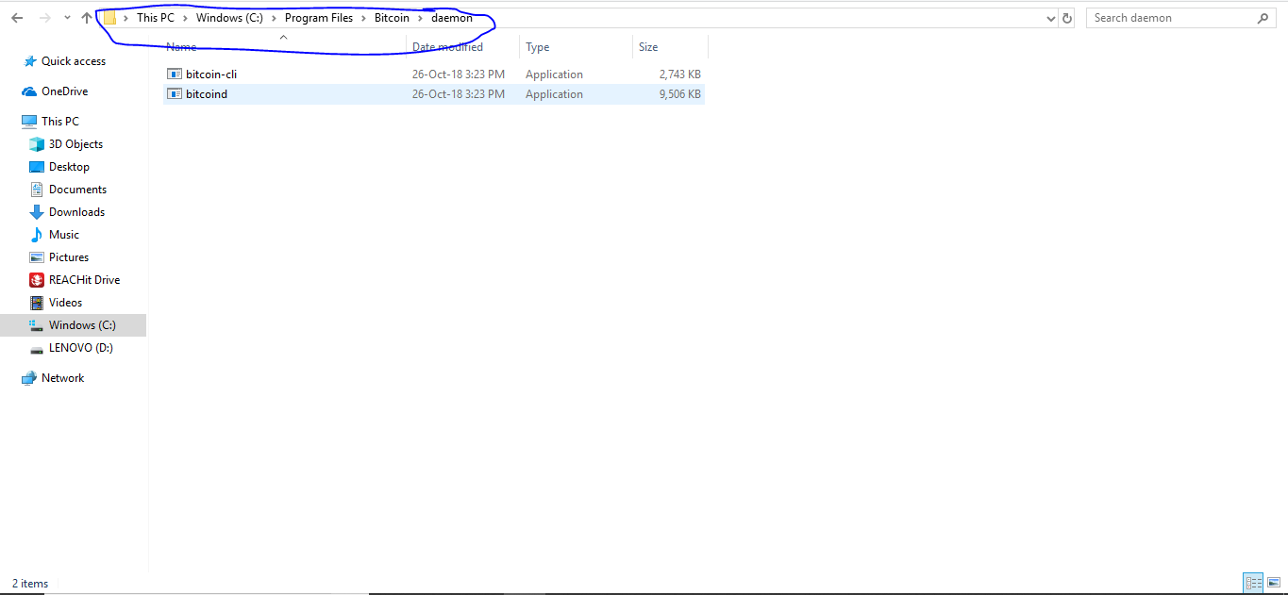

1. First create path in environment variables

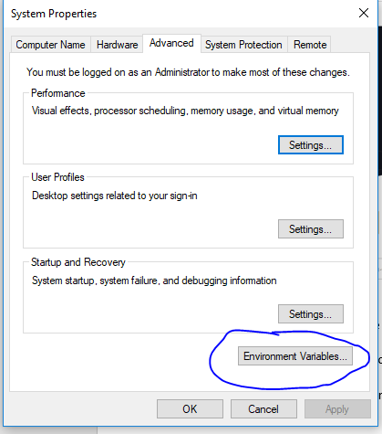

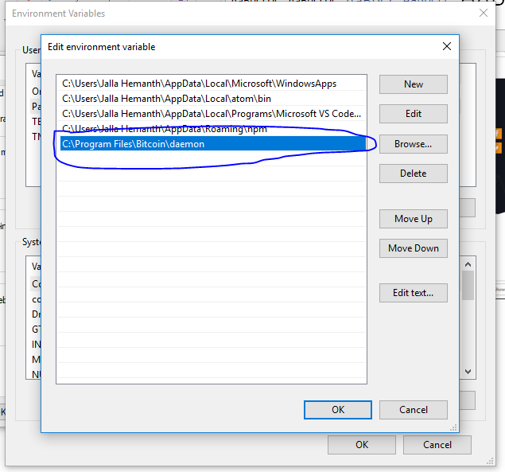

1. Create path in system variables also

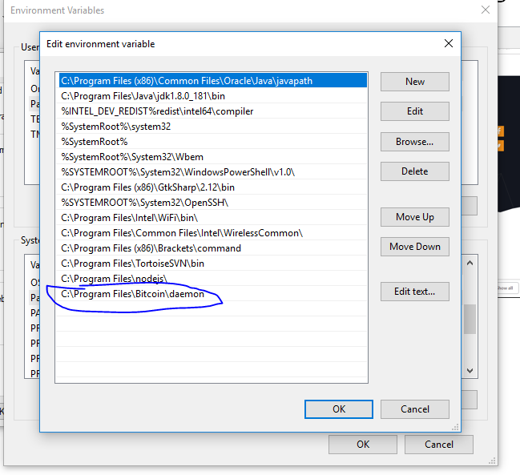

1. After creating path than open command prompt and start process as given below

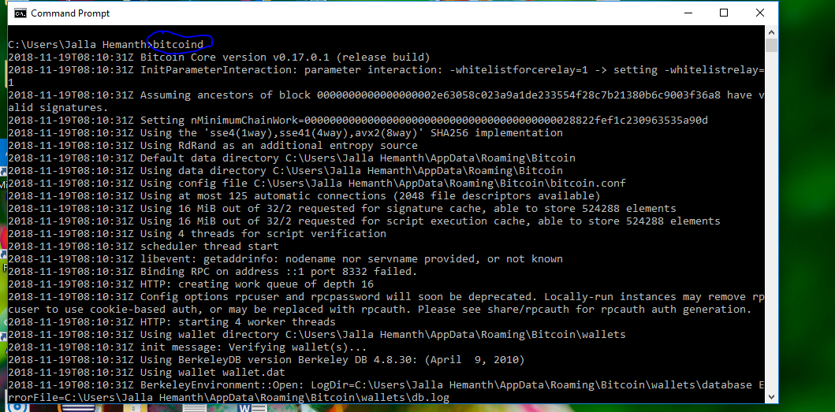

* To run the below script in node.js follow the steps given below:

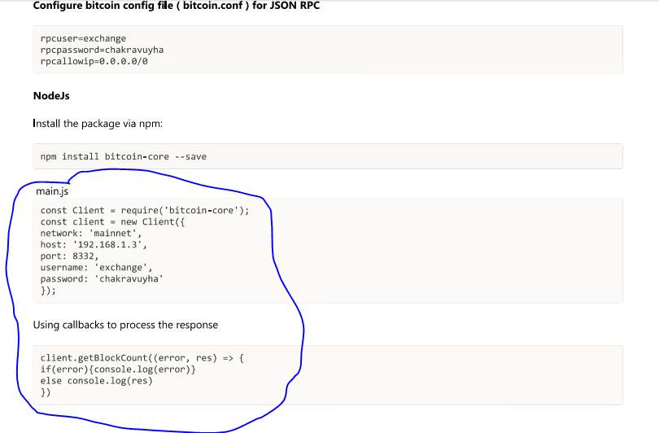

* First you need to make bitcoin configuration as shown below:

1. Open the appdata as shown below

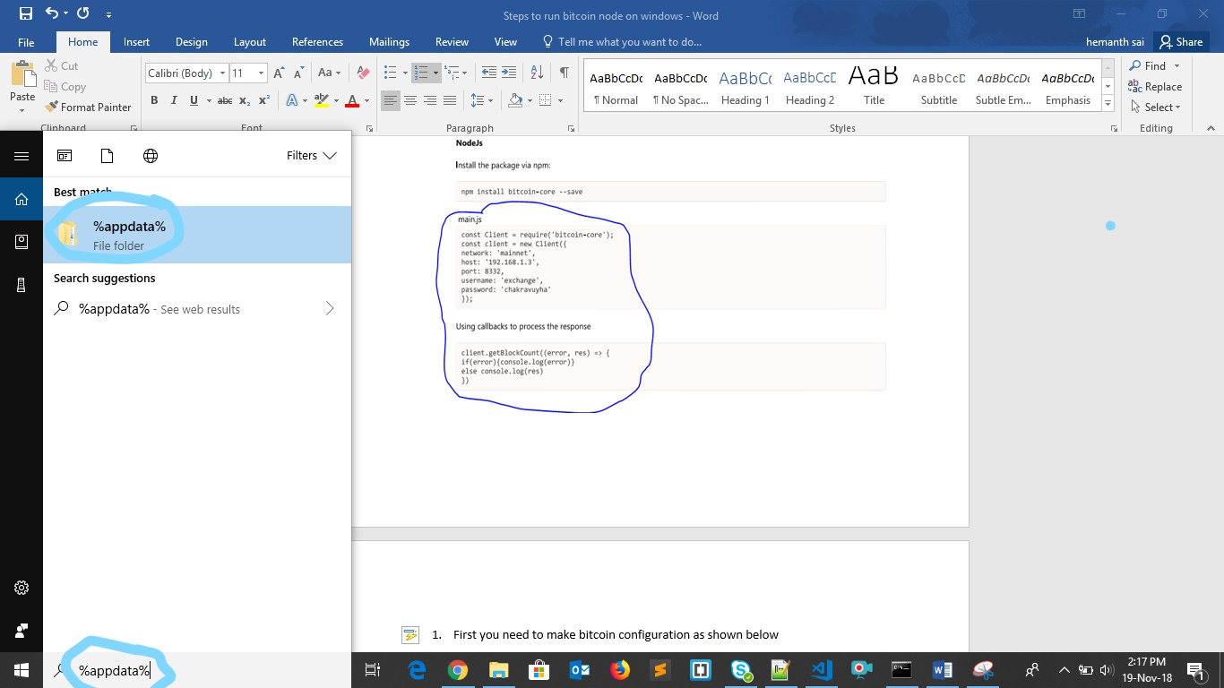

1. Select bitcoin folder as shown below

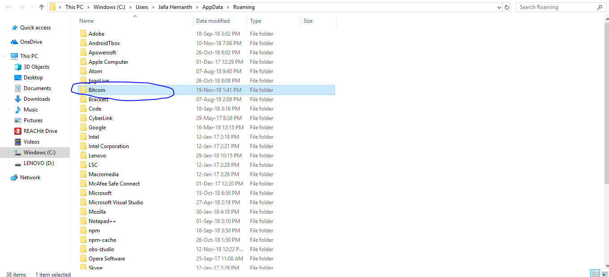

1. Select bitcoin.conf file and edit with notepad++ as shown below

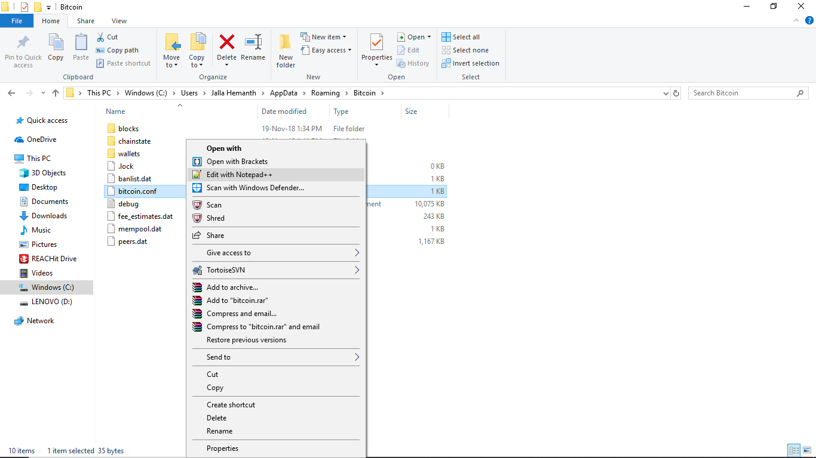

1. Create these configuration and save it and then run the code than u will get the output.

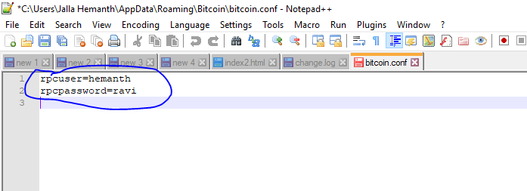

**This is the output for my code**

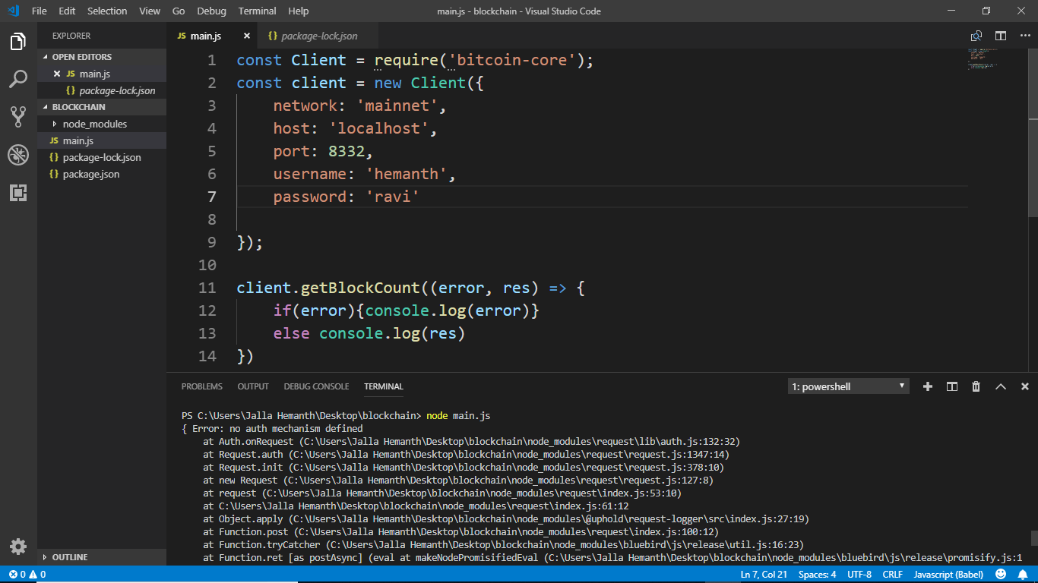

* **First run the command prompt as shown above and then run this node.js code. Than only you will get output.**